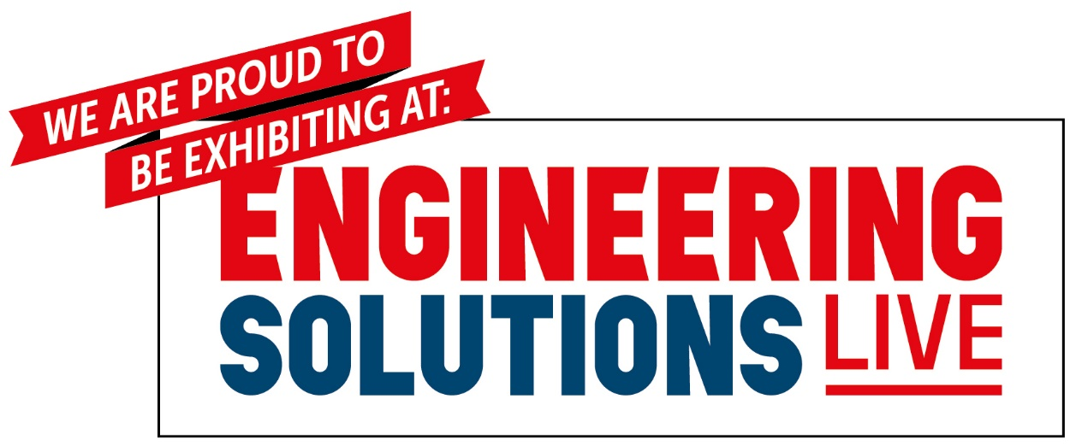

Dear [Customer First Name],

We have some news…

In March we will be showcasing our latest products/ services at the renowned Engineering Solutions Live.

Engineering Solutions Live combines four complementary events: Engineering Materials Live, the FAST Show, Make Measurement Matter and PCB Design & Manufacturing Live to create a must-attend, single-day forum for all engineering, design and manufacturing professionals.
We will be on stand number ??. Whether you’re an existing client or interested to learn more about us, please accept our invitation to come along and see how we can cater our products/ services to fulfil your needs.
Event Details
Date: 9th September 2021
Time: 8.30am – 2.30pm
Location: British Motor Museum, Banbury Road, Gaydon, Warwickshire, CV35 0BJ
By attending Engineering Solutions Live you will have access to a number of technical workshop sessions led by industry thought leaders, the chance to network with your industry peers, and what’s more, joining us will be over 100 other market-leading engineering and manufacturing suppliers and solution providers for you to visit. So, don’t miss out on this unique opportunity to keep up to date with industry trends and thrive in the years ahead.
Entry and parking are free-of-charge for all visitors. What’s more, you’re ticket to Engineering Solutions Live also gives you full access to the British Motor Museum, providing an exhilarating close-up view of the cars that made this country!

>> Register for your FREE place here
Visit www.engineeringsolutionslive.co.uk for more information.
Follow the event on social media!

[Insert Signature]

